|  |
| --- |
| Вариант |
| 3 | |
| 10 | |

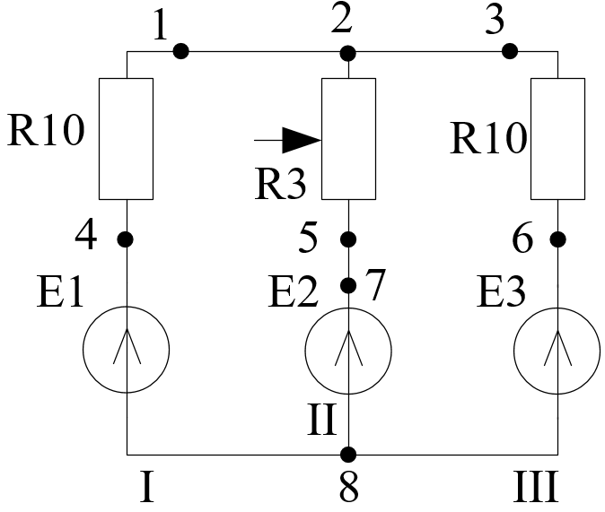

|  |  |  |
| --- | --- | --- |
| № Варианта | R3, % | Е |
| 3 | 80 | Е3 |

|  |  |  |  |  |  |  |  |  |
| --- | --- | --- | --- | --- | --- | --- | --- | --- |
| № Ветви | Рассчитанные | | Измеренные | | Δ U, В | εU, % | Δ I, А | εI, % |
| Iрасч, A | Uрасч, B | Iизм, A | Uизм, B |
| I |  |  | 0.296 | 3.01 |  |  |  |  |
| II |  |  | 0.13 | 1.5 |  |  |  |  |
| III |  |  | 0.135 | 1.53 |  |  |  |  |